1. Select* FROM `tb_dokter` ORDER BY id_dokter DESC

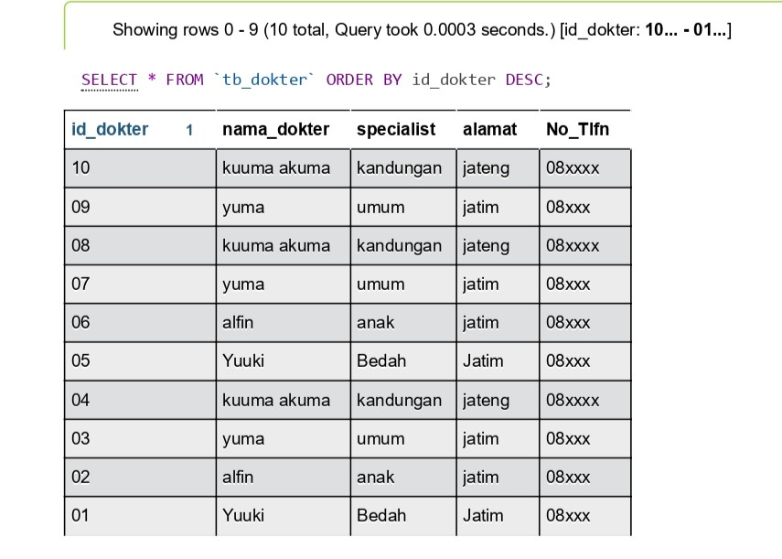

1. Select* FROM `tb_dokter` ORDER BY specialist ASC

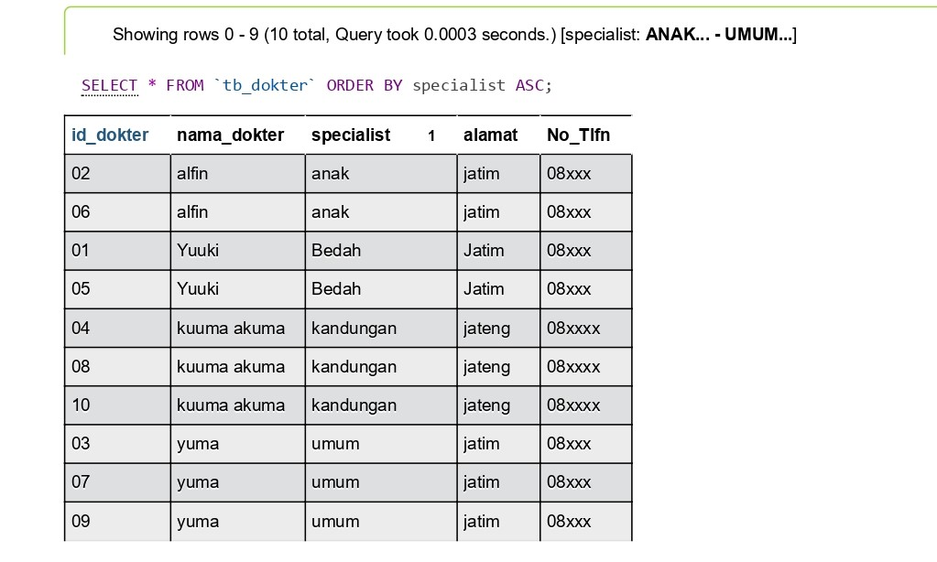

1. SELECT *FROM `tb_dokter` WHERE alamat LIKE ‘%Jatim%’

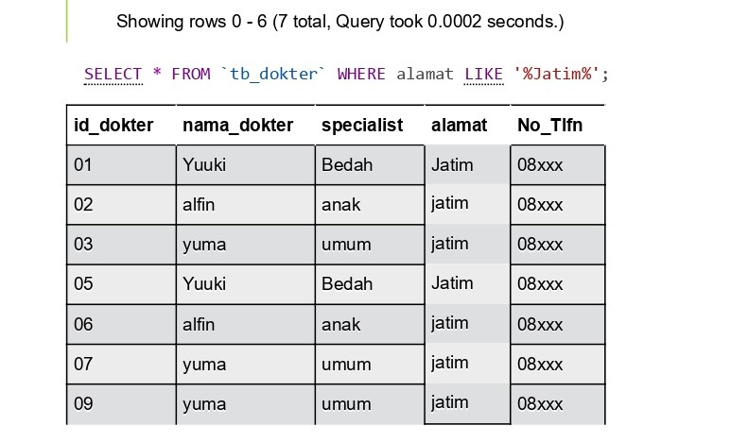

1. SELECT id_obat, SUM(qty_stock) as total FROM tb_obat GROUP BY id_obat

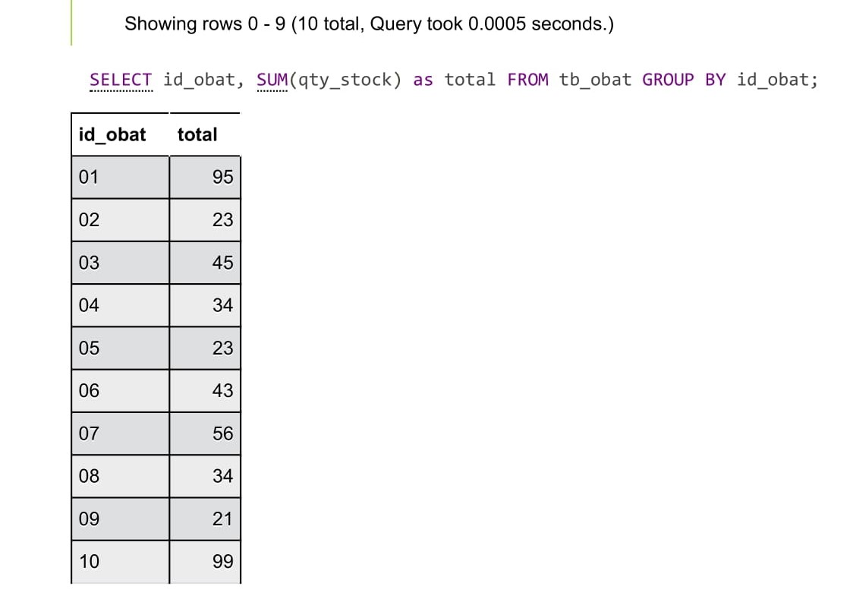

1. SELECT COUNT(umur_pasien) FROM tb_pasien

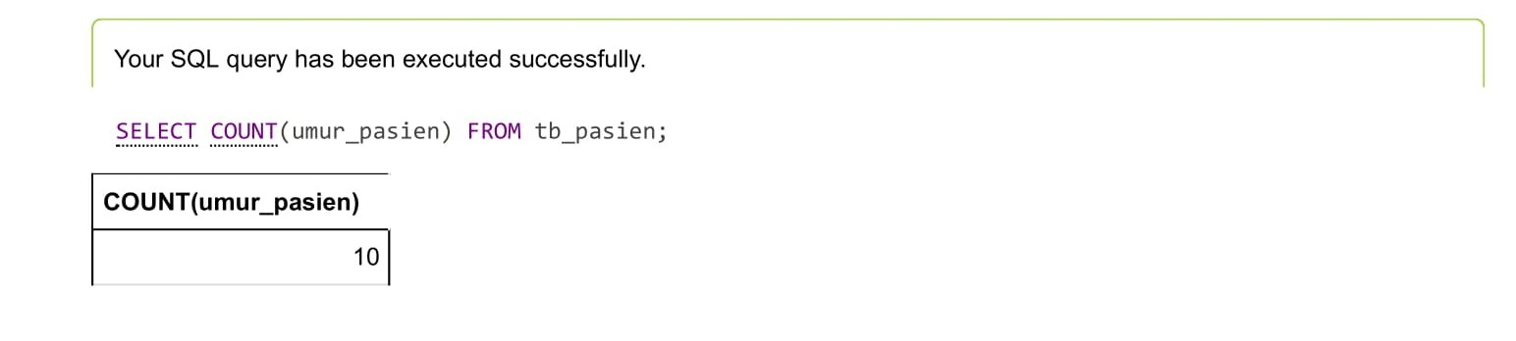

1. SELECT AVG(umur_pasien) FROM tb_pasien

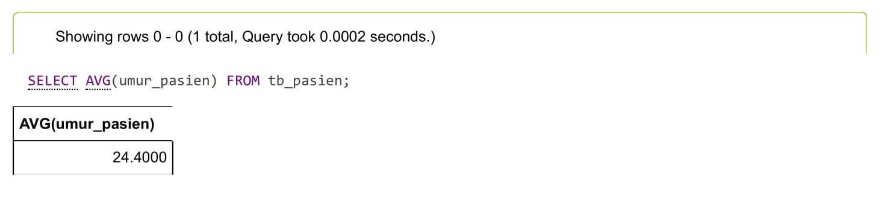

1. SELECT SUM(umur_pasien) FROM tb_pasien

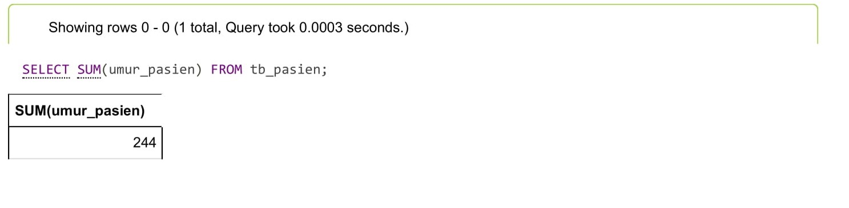

1. SELECT MIN(umur_pasien) FROM tb_pasien

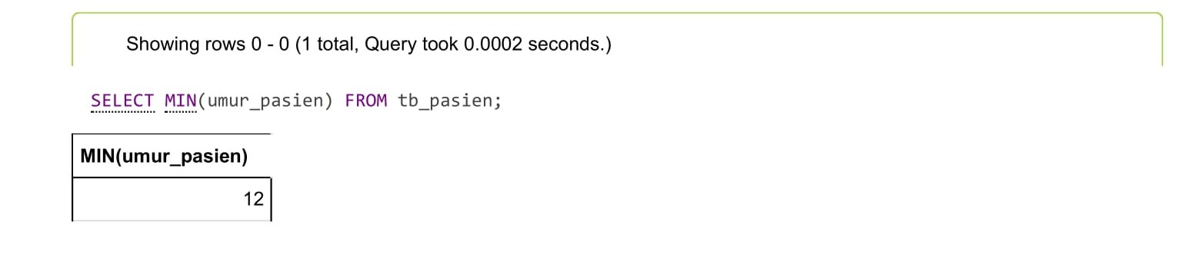

1. SELECT MAX(umur_pasien) FROM tb_pasien

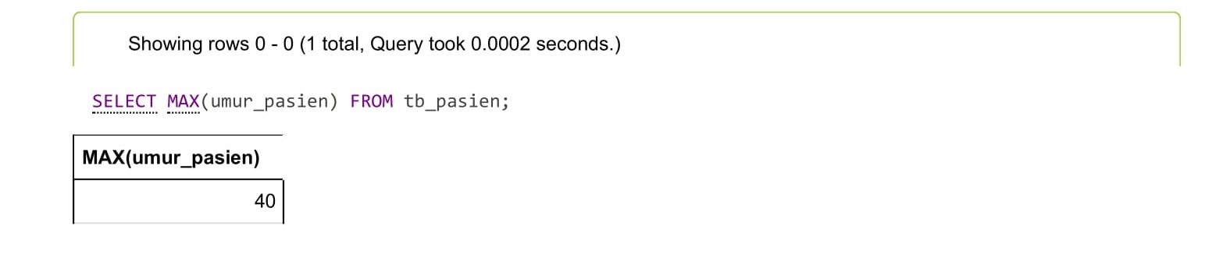

1. SELECT MAX* FROM `tb_pasien` WHERE nama_pasien NOT LIKE ‘%u%’

